Assignment:5.3
Salupala NAVEEN YADAV
Batch:42
2303A52230
Task 1: simple login System
Prompt:
Write a short Python program for a console-based login system using a dictionary to store user data. The program must display a menu in a loop with options 1.Register, 2.Login, 3.Exit.During registration, ask for username and password, check if the username already exists, and allow a maximum of 10 users only. If the limit is reached, display a message.During login, ask for username and password and verify credentials using the dictionary. Display success or invalid message.Use a while True loop, conditional statements, and keep the code simple without using functions.
Code:
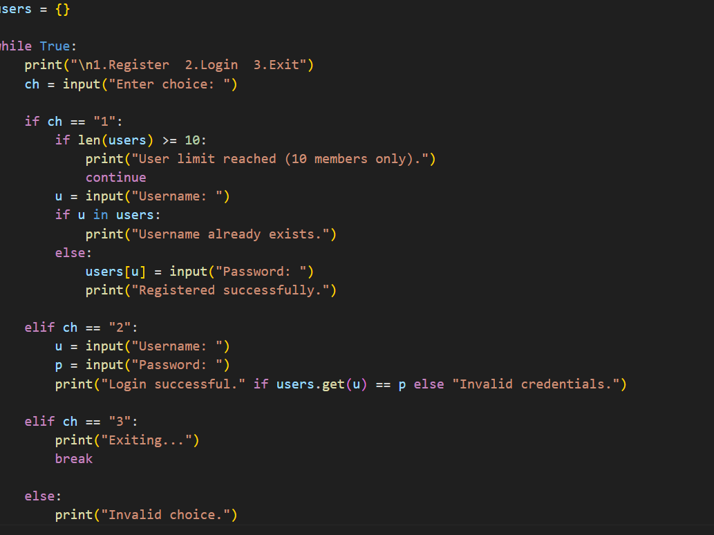
Output:
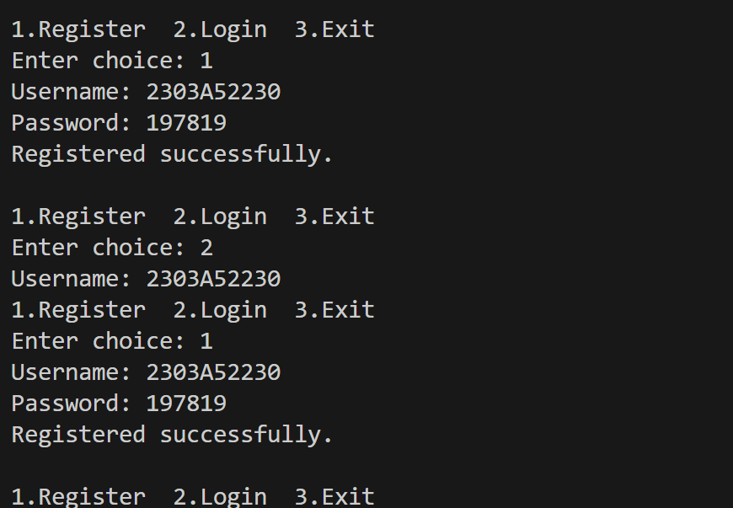

Justification:
This program implements a simple login system using a dictionary to store usernames and passwords for quick access. A while loop is used to display the menu repeatedly until the user exits. The registration part prevents duplicate usernames and limits the system to 10 users. The login part checks whether the entered credentials match the stored data. Conditional statements control the program flow. The program demonstrates basic concepts like dictionary usage, loops, and user authentication.

Task2:Loan approval System
Prompt:
Write a Python console program for a Loan Approval System using a while True loop to process multiple applicants. Display a title line. Take inputs: name, gender (male/female), monthly income (float), and credit score (int).
If credit score > 700 and income > 30000:
If gender is male print "Loan Approved"
Else print "Loan Under Review"
Otherwise print "Loan Rejected".
After each applicant ask "Check another applicant? (yes/no):". If the answer is not "yes", print "System closed." and stop. Use gender.lower() for comparison.

Code:
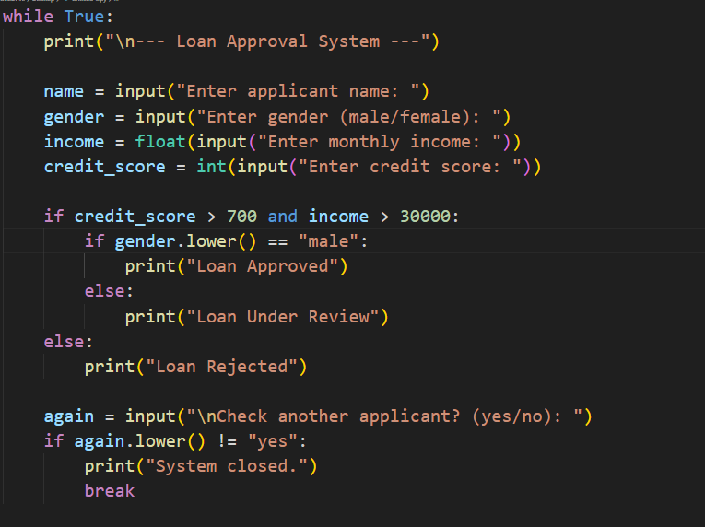

Output:

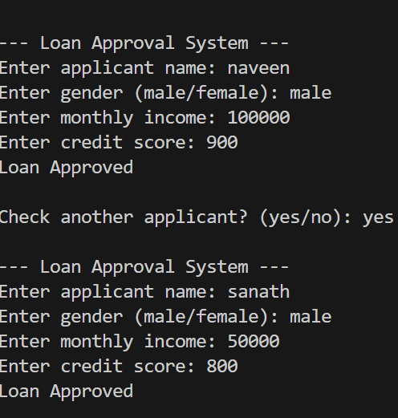

Justification:

The program repeatedly takes applicant details, checks income and credit score to approve or reject loans, uses gender to decide between “Approved” or “Under Review,” and allows the user to process multiple applicants until they choose to exit.

Task3:Binary search using recusion

Prompts:
Write a Python program for recursive binary search on the sorted list [10, 20, 30, 40, 50, 60, 70].
Create a function binary_search(arr, low, high, key) with base case low > high returning -1.
Return index if key matches middle element; else search left or right half recursively.
Add clear comments for each step.
In main, use a while True loop to allow multiple searches.
Ask user for element to search, call the function, display result, and ask "Search another element? (yes/no):" to continue or stop.
Include comments in the main program.

Code:

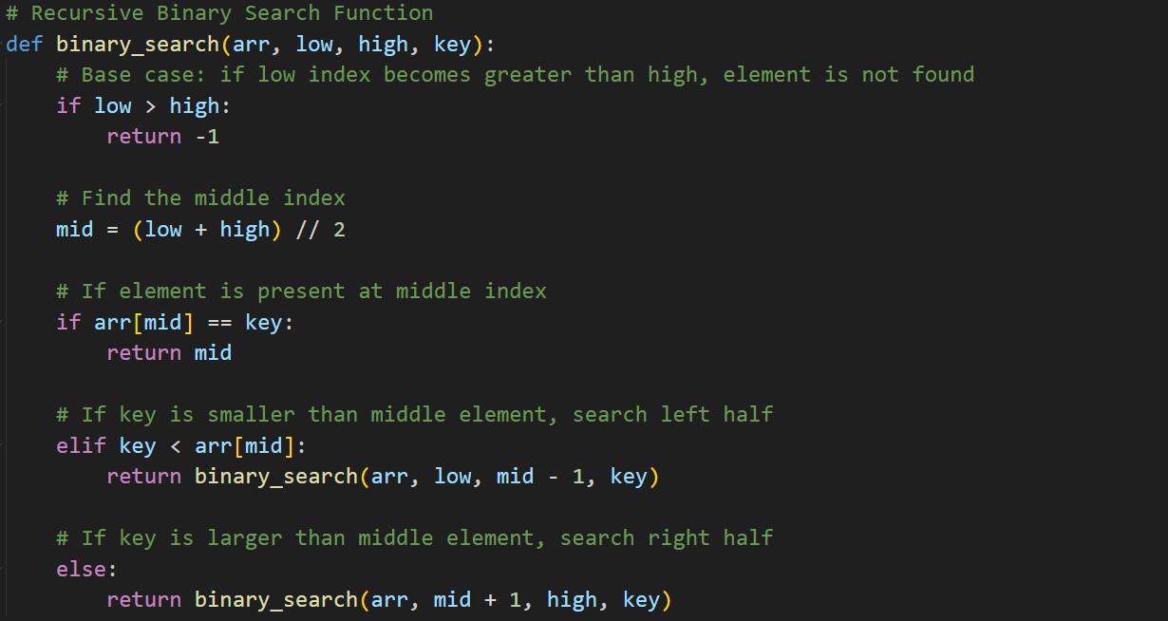

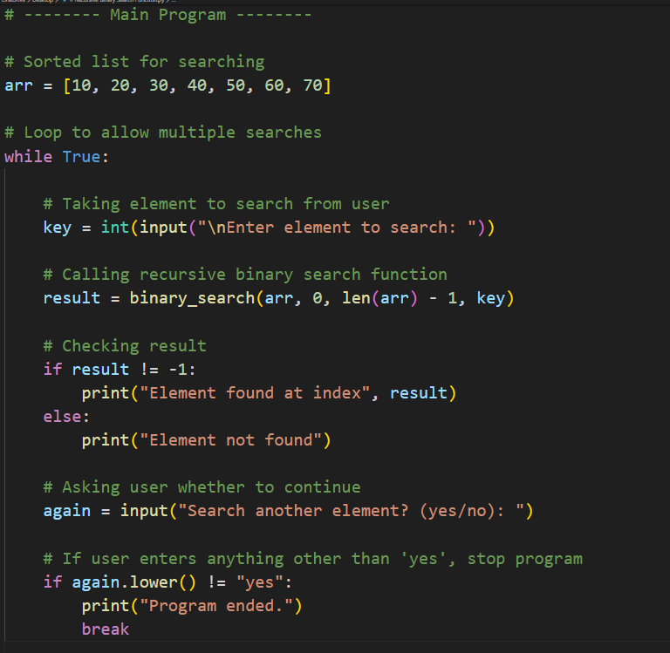

Output:

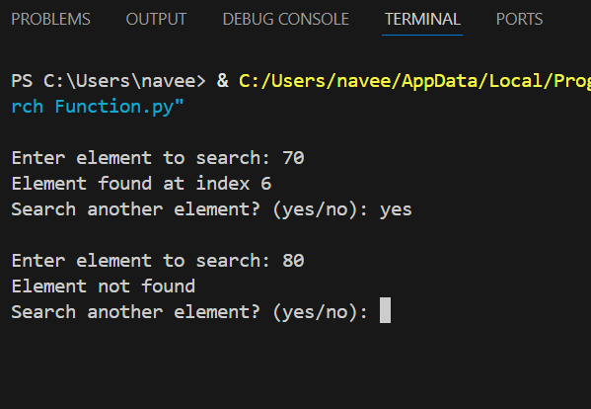

Justification:

This program implements a recursive binary search on a sorted list. It demonstrates the use of recursion by dividing the search space into smaller halves until the element is found or the search ends. The base case handles the scenario when the element is not present. The program uses a loop in the main program to allow searching for multiple elements without restarting. Clear inline comments explain each step, making it easy to understand for beginners, transparent, and suitable for demonstrating recursion, decision-making, and iterative input handling.

Task4:Job applicant scoring system

Prompt:

Write a Python console program that scores job applicants in a while True loop. Take inputs: name, gender, skills (out of 10), years of experience, and education (Bachelors/Masters/PhD). Initialize score = 0, add skills × 5 and experience × 3, add 10 for Masters and 15 for PhD, and add 5 extra points if gender is male (for bias analysis). Print the final score with the applicant name. After each applicant ask "Evaluate another applicant? (yes/no):" and stop if the answer is not "yes". Include comments.

Code:

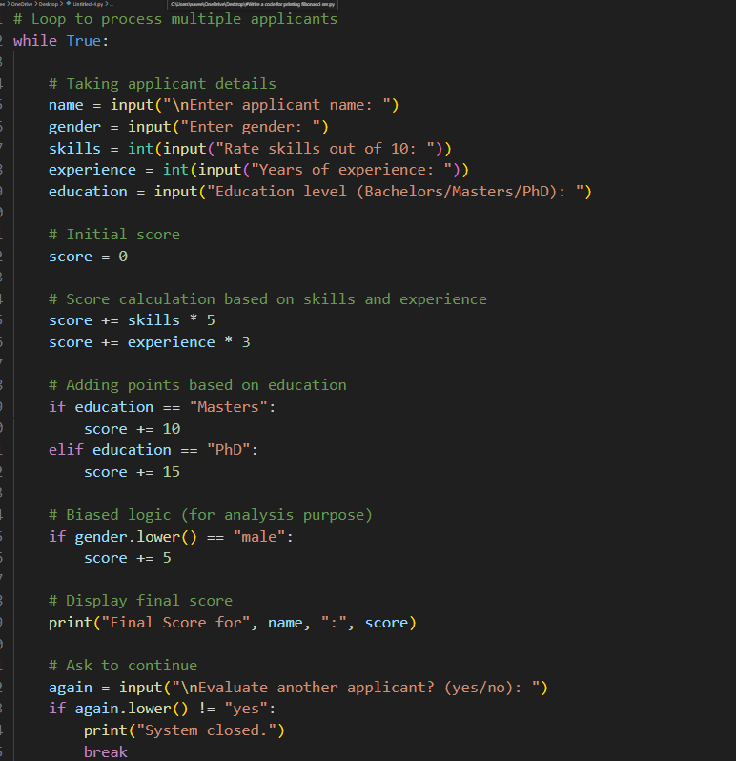

Output:

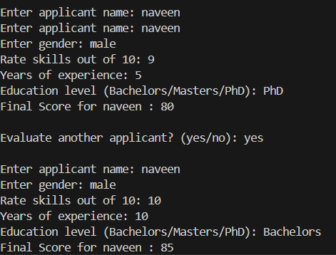

Justification:
This program scores job applicants using skills, experience, and education. A loop allows evaluating multiple applicants. The gender condition is intentionally added to demonstrate bias, helping analyze fairness and ethical issues in AI systems.

Task5: Python code snippet that processes user or employee details.

Prompt:

Write a simple Python program for an Employee Record System.
The program should,Take employee name, gender (male/female), age, and salary as inputs,Use gender-based conditions to calculate bonus
Give 10% bonus for males, 12% bonus for females, and 8% for others,Display all employee details and the bonus,Keep the program basic using if-elif-else and input().

Code:

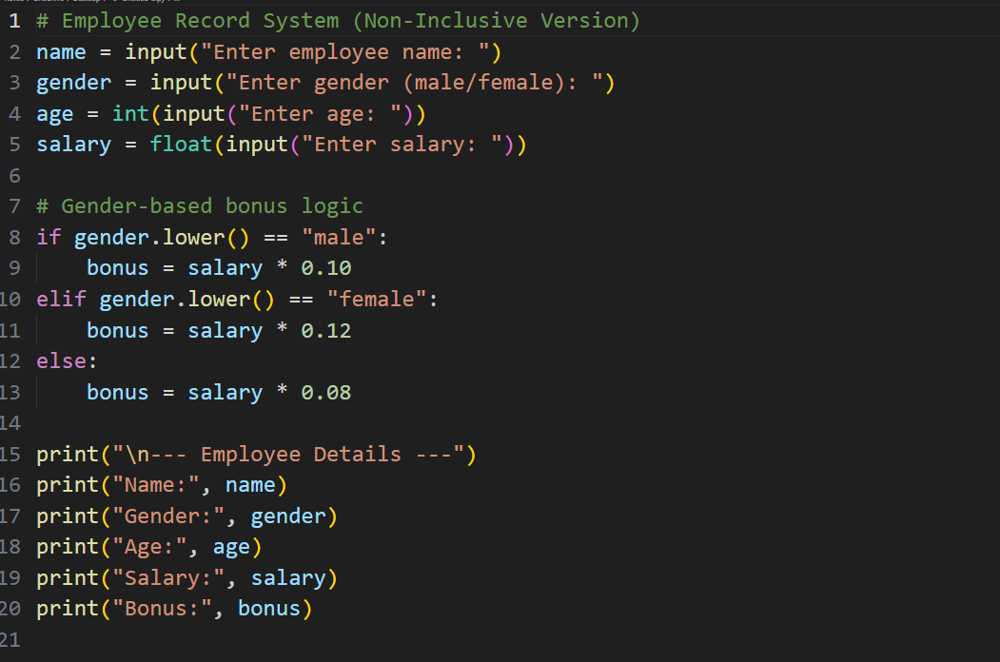

Output:

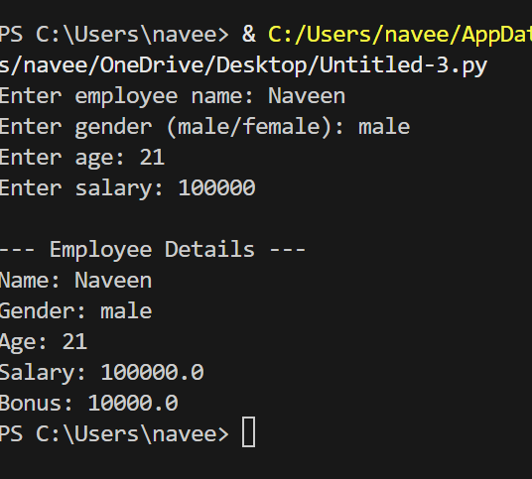

Justification:

The original program is non-inclusive because it uses gender-specific inputs and applies different bonus calculations based on gender. This assumes a gender binary and introduces potential bias in decision-making. Such logic is not fair or necessary for employee evaluation, as job-related factors like experience or performance should be used instead.

